**SECTION A**

1. State one use of trees in our environment.

______________________________________________________________________________

1. Identify any one sign of pest damage in crops.

______________________________________________________________________________

1. How is BCG vaccine different from polio vaccine in the way they are administered?

______________________________________________________________________________

1. Which part of a fish detects sound waves in water?

______________________________________________________________________________

1. Give one importance of wind to plants.

______________________________________________________________________________

1. Identify the product got from cattle whose body shape is shown below.
2. Why is a bat classified under mammals?

______________________________________________________________________________

1. Name the component of blood responsible for clotting blood in cuts.

______________________________________________________________________________

1. Why is burning of wood to ash called a chemical change?

______________________________________________________________________________

1. What do the eggs of a cockroach hatch into?

______________________________________________________________________________

1. Which element of PHC is promoted through proper disposal of rubbish?

______________________________________________________________________________

1. Name the deficiency disease caused by lack of vitamin **A**in the diet.

______________________________________________________________________________

1. Identify any one method of harvesting root crops from the garden.

______________________________________________________________________________

1. Which part of a flower has the same role as the testicles of a bull?

______________________________________________________________________________

1. Give a reason why worker bees are not able to lay eggs.

______________________________________________________________________________

1. In which one state of matter does heat travel by convection?

______________________________________________________________________________

1. Why should we tepid sponge someone with fever?

______________________________________________________________________________

1. 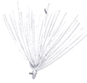How is the seed shown below dispersed?

_________________________________________________________

_________________________________________________________

1. Why are green plants unable to make food at night?

______________________________________________________________________________

1. Give one example of a living resource in the environment.

______________________________________________________________________________

1. Identify one poultry disease caused by protozoa.

______________________________________________________________________________

1. In which way is a mushroom similar to a moss plant?

______________________________________________________________________________

1. Give one importance of cilia in the nostrils of mammals.

______________________________________________________________________________

1. Mention one example of a stem tuber.

______________________________________________________________________________

1. Write down any one device used to store sound.

______________________________________________________________________________

1. State one way water gets contaminated at the source.

______________________________________________________________________________

1. Identify any one example of a plant fibre.

______________________________________________________________________________

1. Why does a medical worker dip a clinical thermometer in spirit before using it on another person?

______________________________________________________________________________

1. Why is sugar used in the making of ORS?

______________________________________________________________________________

1. Name one body organ severely damaged by excessive consumption of alcohol.

______________________________________________________________________________

1. Mention one example of a disease that is spread through droplet infection.
2. Identify the type of tropism shown below.

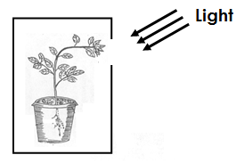

___________________________________________________________

1. State one danger of hook worm infestation to the human body.

___________________________________________________________

1. Give one way in which animals depend on plants.

______________________________________________________________________________

1. Suggest one way a crop farmer can control pests without using chemicals.

______________________________________________________________________________

1. Name one by product of respiration.

______________________________________________________________________________

1. State one way in which a child gets natural immunity.

______________________________________________________________________________

1. Identify one example of a water habitat disease.

______________________________________________________________________________

1. How is blood carried by the pulmonary vein different from that carried by the pulmonary artery?

______________________________________________________________________________

______________________________________________________________________________

1. Give one importance of a school health committee.

______________________________________________________________________________

**SECTION B**

1. 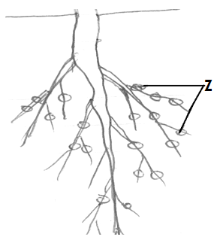**Study the diagram below and use it to answer questions that follow.**
2. Name the type of root system shown above.

__________________________________________________________

1. Which group of crops has such roots?

_________________________________________________________

1. State the function of structures marked **Z**.

_________________________________________________________

1. How is osmosis important to plants?

_________________________________________________________________________

1. a) Give any two advantages of keeping local breeds of cattle.

i) _____________________________________________________________________________

ii)_____________________________________________________________________________

b) Name the fuel obtained from cow dung.

______________________________________________________________________________

c) Why do farmers mainly rear Friesian breed of cattle?

______________________________________________________________________________

1. a) How are insects like moths able to locate flowers at night?

______________________________________________________________________________

b) Mention any two living agents of pollination.

i) _____________________________________________________________________________

ii)_____________________________________________________________________________

c) What happens when pollen grains land on the stigma?

______________________________________________________________________________

1. a) Identify the groups of vertebrates to which the following animals belong.

i) snake _____________________________________________________________________

ii) Toad______________________________________________________________________

iii) Whale____________________________________________________________________

b) How is the reproduction of a whale similar to that of a snake?

______________________________________________________________________________

______________________________________________________________________________

1. a) Mention any one cause of soil erosion.

______________________________________________________________________________

b) Suggest two ways of controlling soil erosion in a hilly area.

i) _____________________________________________________________________________

ii)_____________________________________________________________________________

c) Identify any one agent of soil erosion.

______________________________________________________________________________

1. a) Name the type of teeth used for:

i) Biting food _________________________________________________________________

ii) Tearing flesh________________________________________________________________

b) Why should food be chewed properly before being swallowed?

______________________________________________________________________________

c) Which disorder of the digestive system leads to blockage of food movement along

the alimentary canal?

______________________________________________________________________________

1. **Study the diagram below and use it to answer questions that follow.**

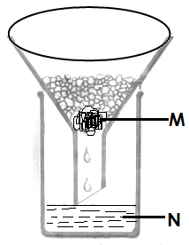

1. Identify the method of obtaining clean water shown in the diagram

______________________________________________________________

1. Give the scientific name given to substance marked;
2. **M**__________________________________________________
3. **N** ___________________________________________________
4. Why is water got through the above method not safe for drinking?

______________________________________________________________________________

1. a) Which part of the human body is affected by the following diseases?

i)scabies ____________________________________________________________________

ii) conjunctivitis_______________________________________________________________

b) Name the vector that spreads rabies.

______________________________________________________________________________

1. Identify one disease likely to breakout in an area due to poor sanitation.

______________________________________________________________________________

1. **Study the table below and fill in the missing information**

|  |  |  |
| --- | --- | --- |
| **Sources of food** | **Food value** | **Deficiency disease** |
| Fruits | Vitamin **C** | __________________________ |
| Beans | ______________________ | Kwashiorkor |
| Iodised salt | Iodine | _________________________ |
| _____________________ | Carbohydrates | marasmus |

1. 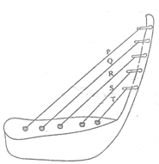**Use the diagram of a musical instrument shown below to answer questions that follow.**
2. To which group of instruments does the above shown instrument belong?

______________________________________________________________________________

1. How is the above instrument played?

______________________________________________________________________________

1. Which string will produce the highest pitched sound?

______________________________________________________________________________

1. How are echoes reduced in cinema halls?

______________________________________________________________________________

1. a) State the difference between **a burn** and **scald**.

______________________________________________________________________________

______________________________________________________________________________

b) Which First Aid is given in case of each of the following;

i) Burns and scalds ____________________________________________________________

ii) Fractures__________________________________________________________________

iii) Snake bite_________________________________________________________________

1. a) State any two reasons why people smoke.

i) _____________________________________________________________________________

ii)_____________________________________________________________________________

b) Give one danger of smoking to a pregnant woman.

______________________________________________________________________________

c) Besides smoking, give any other way how drugs are introduced into the body.

______________________________________________________________________________

1. a) How is each of the following plants propagated;

i) Sugar canes?_________________________________________________________________

ii) Onions?_____________________________________________________________________

iii) Bananas?__________________________________________________________________

b) State one advantage of growing crops vegetatively over seeds.

______________________________________________________________________________

1. a) Give one example of each of the following

i) Renewable resources _________________________________________________________

ii) Non-renewable resources _____________________________________________________

b) Suggest two ways of conserving resources in the environment.

i) _____________________________________________________________________________

ii) ____________________________________________________________________________

1. a) State the function of the heart in the human body.

______________________________________________________________________________

b) Give the functions of the following components of blood in the body.

i) White blood cells

______________________________________________________________________________

ii) Red blood cells

______________________________________________________________________________

c) Why do arteries have thicker muscular walls than veins?

______________________________________________________________________________

**SECTION A**

1. Name the first set of teeth to appear in a human.

____________________________________________________________________________

1. Give one reason why farmers rear birds.

____________________________________________________________________________

1. How useful is an echo to a pilot?

____________________________________________________________________________

1. Which property of air enables one to spray perfume on the body?

____________________________________________________________________________

1. State one process that helps in soil formation.

____________________________________________________________________________

1. How is the tool below useful to a farmer?

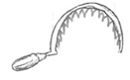______________________________________________________

______________________________________________________

1. Which type of weather drives wind mills?

____________________________________________________________________________

1. Why does a butterfly die when its abdomen is covered with cassava flour?

____________________________________________________________________________

1. Name one exotic breed of rabbit reared in Uganda.

____________________________________________________________________________

1. By which process do plants absorb water from the soil?

____________________________________________________________________________

1. Identify one method of applying fertilizers in the soil.

____________________________________________________________________________

1. State one effect of alcoholism to the family.

____________________________________________________________________________

1. In which way is a burn similar to a scald?

____________________________________________________________________________

1. Calculate the density of the figure below if its mass is 84g..

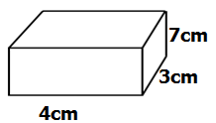

1. Suggest one way P.6 pupil can promote sanitation in his/her classroom.

____________________________________________________________________________

1. Why do small drums produce high pitched sound?

____________________________________________________________________________

1. Name the digestive juice produced in the stomach.

____________________________________________________________________________

1. Write down one example of a sea mammal.

____________________________________________________________________________

1. State one effect of heat on matter.

____________________________________________________________________________

1. What do we call the blood vessels that carry blood away from the heart?

____________________________________________________________________________

1. How is sugar helpful to a dehydrated child?

____________________________________________________________________________

1. Name the fungus that helps in fermentation of alcohol.

____________________________________________________________________________

1. How does the cork of a vacuum flask control heat loss?

____________________________________________________________________________

1. Identify any one quality of a good first aider.

____________________________________________________________________________

1. How is a housefly adapted to spreading disease germs?

____________________________________________________________________________

1. Why do farmers dock the female sheep?

____________________________________________________________________________

1. State the importance of a latrine in a clean home.

____________________________________________________________________________

1. How can a farmer improve upon his local breeds of goats?

____________________________________________________________________________

1. In the space below draw a leaf with parallel venation.
2. Why do worker bees visit flowers?

____________________________________________________________________________

1. Identify one way in which drugs are taken into the body.

____________________________________________________________________________

1. Name one vertebrate that uses a shell for protection?

____________________________________________________________________________

1. Why do doctors dip a clinical thermometer in alcohol before using it on another patient?

____________________________________________________________________________

1. How do bacteria reproduce?

____________________________________________________________________________

1. Why is a rain gauge placed in an open place?

____________________________________________________________________________

1. Which vitamin improves upon our vision?

____________________________________________________________________________

1. 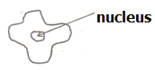State the function of the blood cell below in the body.

_________________________________________________________________________________________________________________________________

1. Identify the body system that is severely destroyed by smoking.

____________________________________________________________________________

1. Give one condition that may force a mother to bottle feed her baby.

____________________________________________________________________________

1. Mention one cause of soil exhaustion.

____________________________________________________________________________

**SECTION B**

1. a) Why is cholera regarded as a communicable disease?

____________________________________________________________________________

b) Besides cholera, mention two other communicable diseases.

i) _________________________________________________________________________

ii) _________________________________________________________________________

c) Suggest one way of controlling the spread of cholera.

____________________________________________________________________________

1. a) State any two reasons why people smoke.

i) _________________________________________________________________________

ii) _________________________________________________________________________

b) Name one disease caused by smoking.

____________________________________________________________________________

c) How is **passive smoking** different from **active smoking**?

____________________________________________________________________________

____________________________________________________________________________

1. a) Name any two examples of root crops.

i) _________________________________________________________________________

ii) _________________________________________________________________________

b) Mention one pest that attacks root crops.

____________________________________________________________________________

c) Suggest one way of caring for crops in the garden.

____________________________________________________________________________

1. a) Name one biological change that occurs in both plants and animals.

____________________________________________________________________________

b) Give one example of each of the following;

i) Chemical change___________________________________________________________

ii) Physical change__________________________________________________________

c) Mention one human activity that spoils the environment.

____________________________________________________________________________

1. a) State two ways in which pineapples are propagated.

i) _________________________________________________________________________

ii) _________________________________________________________________________

b) Mention one crop which can be propagated in the same way like a pineapple.

____________________________________________________________________________

c) Identify one common pest of pineapple.

____________________________________________________________________________

1. a) State any two components of air besides carbondioxide.

i) _________________________________________________________________________

ii) _________________________________________________________________________

b) Why is carbondioxide used in fire extinguishers?

____________________________________________________________________________

c) How is **wind** different from **air**?

____________________________________________________________________________

____________________________________________________________________________

1. 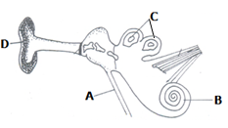Study the diagram below and use it to answer questions that follow.
2. Name the parts labeled:

i) **D**_________________________________ ii) **A**_______________________________

1. State the function of part **C**.

__________________________________________________________________________

1. Name one disease that attacks the human ear.

__________________________________________________________________________

1. a) Why is a scorpion called an invertebrate?

__________________________________________________________________________

b) To which group of vertebrates does a frog belong?

__________________________________________________________________________

1. Why is a fish called a cold blooded animal?

__________________________________________________________________________

d) State one similarity between birds and mammals.

__________________________________________________________________________

1. Use the diagram below to answer questions that follow.

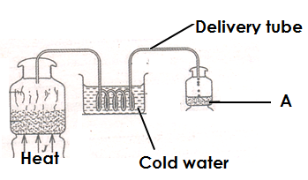

1. Name the method of making alcohol shown above.

__________________________________________________________________________

1. What role is played by cold water in the above process?

__________________________________________________________________________

1. State the scientific name given to the liquid in container A.

__________________________________________________________________________

1. State any one use of alcohol to people.

__________________________________________________________________________

1. a) Besides egg eating, name any other poultry vice.

__________________________________________________________________________

b) Give one cause of egg eating in poultry.

__________________________________________________________________________

c) Suggest two ways of controlling vices in poultry.

i) _________________________________________________________________________

ii) _________________________________________________________________________

1. 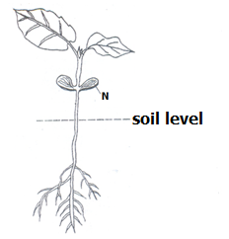Study the diagram below and use it to answer questions that follow.
2. What type of germination is shown in the diagram?

_________________________________________________

1. Identify any one seed that undergoes the above mentioned type of germination.

_________________________________________________

1. Name part marked **N**.__________ _____________________
2. Give one factor that may make a seed fail to germinate when all conditions are present.

__________________________________________________________________________________________________

1. Match the following weather instruments to their function

**A B**

Hygrometer speed of wind

Barometer amount of rainfall received

Rain gauge atmospheric pressure

Anemometer strength of wind.

Amount of water vapour in the atmosphere

1. Hygrometer______________________________________________________________
2. Barometer_______________________________________________________________
3. Rain gauge_______________________________________________________________
4. Anemometer______________________________________________________________
5. a) Name the component of soil that increases its fertility.

__________________________________________________________________________

b) Write down two ways of maintaining soil fertility.

i) _________________________________________________________________________

ii) _________________________________________________________________________

c) How does bush burning cause soil erosion.

__________________________________________________________________________

1. a) What do we call the sudden happening that causes injury to the body?

__________________________________________________________________________

b) Give two reasons why people with injuries should be given First Aid.

i) _________________________________________________________________________

ii) _________________________________________________________________________

c) Why should we tie slightly above the bitten part when giving First Aid for a snake

bite?

__________________________________________________________________________

1. Write down any three requirements needed when starting a farm.

i) _________________________________________________________________________

ii) _________________________________________________________________________

iii) _________________________________________________________________________

b) Mention any one tick borne disease in farm animals.

__________________________________________________________________________

***\*\*\*Good luck\*\*\****

**SECTION A**

1. Name the best soil for modeling.

____________________________________________________________________________

1. Identify one enzyme found in the stomach.

____________________________________________________________________________

1. Mention an invertebrate that defends itself by withdrawing into its shell.

____________________________________________________________________________

1. Give one cause of soil erosion.

____________________________________________________________________________

1. How does heat travel through liquids and gases?

____________________________________________________________________________

Below is a diagram showing the roots of a monocot.

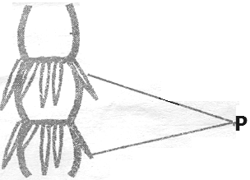

1. State the use of the roots marked **P** to the plant.

____________________________________________________________________________

1. Why do electricity wires appear tight on poles on cold days?

____________________________________________________________________________

1. State any one cause of dehydration.

____________________________________________________________________________

1. In which way are irish potatoes propagated?

____________________________________________________________________________

1. Why are theatre halls usually covered with soft boards?

____________________________________________________________________________

1. Give one importance of the tongue during digestion.

____________________________________________________________________________

1. 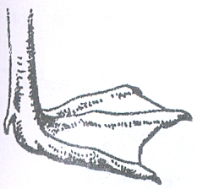**Below is a diagram showing the foot of a bird. Mention one example of a bird with such a foot.**

_____________________________________

1. Why should materials made of iron be painted?

____________________________________________________________________________

1. Why is a P.6 pupil advised to cut finger nails short?

____________________________________________________________________________

1. Name the plant’s response towards light.

____________________________________________________________________________

1. Why is a spider not an insect?

____________________________________________________________________________

1. What is shearing as used in sheep keeping?

____________________________________________________________________________

1. State the digestive juice produced by the stomach walls.

____________________________________________________________________________

1. **In the space below, draw a diagram showing fibrous root system.**
2. How are sunbirds and bees useful to flowers?

____________________________________________________________________________

1. Give any one reason why we give First Aid to accident victims.

____________________________________________________________________________

1. State any one sign of a goat on heat.

____________________________________________________________________________

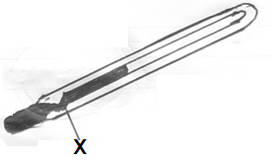**The diagram below shows an instrument. Use it to answer questions 23 and 24.**

1. Name the instrument shown in the diagram

_____________________________________________

1. How is part marked **X** useful in the instrument above?

______________________________________________

______________________________________________

1. What gas do legume plants need to make proteins?

____________________________________________________________________________

1. Mention one way in which vaccines are introduced into our bodies?

____________________________________________________________________________

1. Why is ice called matter?

____________________________________________________________________________

1. Give any one example of a chemical change.

____________________________________________________________________________

1. State any one reason why people drink alcohol.

____________________________________________________________________________

1. How does mulching keep moisture in the soil?

____________________________________________________________________________

1. Of what use is a dustbin in the school compound?

____________________________________________________________________________

1. State the reason why bees sometimes swarm.

____________________________________________________________________________

1. Why do people keep rabbits in their homes?

____________________________________________________________________________

1. Give one activity a community can do to reduce road accidents.

____________________________________________________________________________

1. 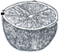To which group of succulent fruits does the fruit in the diagram below belong?

_________________________________________

1. Give one way in fungi are useful to people.

____________________________________________________________________________

1. By what process does smoke move through the chimney?

____________________________________________________________________________

1. State the use of water during seed germination.

____________________________________________________________________________

1. Calculate the density of an object which has a mass of 60 grams and volume of 6cm**3**.

____________________________________________________________________________

1. 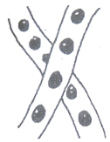Name the amphibian that lays eggs shown in the diagram below.

_________________________________________________________

**SECTION B**

1. **Below are steps used to recover salt with mixed sand, re-arrange the steps**

**correctly.**

1. Filter the mixture.
2. Add water and stir to dissolve the salt.
3. Boil the filtrate until it evaporates to dryness.
4. Collect the mixture and put it into the container.
5. _______________________________________________________________________
6. _______________________________________________________________________
7. _______________________________________________________________________
8. _______________________________________________________________________
9. 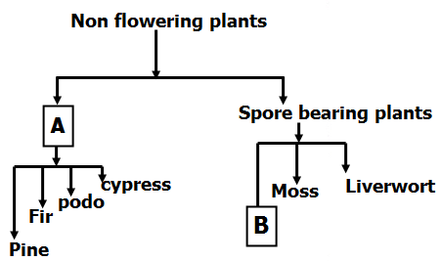Study the diagram below and answer questions.

a) Name parts marked **A** and **B**.

i) **A**________________________________ii) **B**_______________________________

b) How can plants depend on animals?

__________________________________________________________________________

c) How do plants in **A** obtain their food?

_________________________________________________________________________

1. 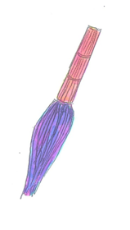a) Which element of Primary Health Care is promoted by using the maternal shown in the

diagram below.

_________________________________

b) Apart from the element of PHC you have mentioned in (a) above, state two other elements

of PHC..

i) _________________________________________________________________________

ii) _________________________________________________________________________

c) Give one way in which a community can promote Primary Health Care.

____________________________________________________________________________

1. a) Mention two vulnerable groups of people involved in breastfeeding.

i)____________________________________(ii)_____________________________________

b) Give one advantage of breastfeeding.

____________________________________________________________________________

c) Write down one disadvantage of bottle feeding.

____________________________________________________________________________

1. a) Name the muscles that make up the heart. ____________________________________________________________________________

b) Why is the left ventricle of the heart thick walled?

____________________________________________________________________________

c) Write down any two functions of blood in the body.

i) _________________________________________________________________________

ii) _________________________________________________________________________

1. Match the instruments in **A** to what they measure (show) in **B**

|  |  |
| --- | --- |
| **A** | **B** |
| Hygrometer | Speed of wind |
| Wind vane | Amount of water vapour. |
| Barometer | Direction of wind. |
| Anemometer | Atmospheric pressure. |

|  |  |  |
| --- | --- | --- |
| i) | Hygrometer | ­­­­­­­­­­­­­­­­­­­­­­­­­­­­___________________________________________________________ |
| ii) | Wind vane | ___________________________________________________________ |
| iii) | Barometer | ___________________________________________________________ |
| iv) | Anemometer | ___________________________________________________________ |

1. a) State the type of smoking where one inhales smoke indirectly from an active smoke.

__________________________________________________________________________

b) Give one disease of the lungs caused by smoking __________________________________

c) Suggest two ways in which an individual can avoid drug dependence.

i) _________________________________________________________________________

ii) _________________________________________________________________________

1. a) Mention one product got from cattle that protect children from kwashiorkor.

__________________________________________________________________________

b) How is a strip cup useful to a cattle keeper?

__________________________________________________________________________

c) Identify the diseases of cattle spread by ticks.

i)__________________________________(ii)____________________________________

1. The diagram below shows three drums. Use it to answer questions below.

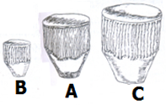

1. Which drum will produce sound with:-
2. The lowest pitch___________________________
3. The highest pitch___________________________

b) How does a drum produce sound?

__________________________________________________________________________

c) Give one reason why sound is stored.

__________________________________________________________________________

1. a) Give two characteristics of living things.

i) _________________________________________________________________________

ii) _________________________________________________________________________

1. State the difference between plants and animals.

__________________________________________________________________________

__________________________________________________________________________

1. How do pupils benefit from orange plants in the school compound?

__________________________________________________________________________

1. a) What are social insects?

__________________________________________________________________________

b) Give two examples of social insects.

i) _______________________________________________________________________

ii) _______________________________________________________________________

c) In which one way are insects useful to people?

__________________________________________________________________________

1. **Oil and water were mixed in a glass as shown below.**

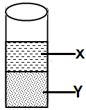

a) Name the liquids **X** and **Y**.

**X**____________________________________________________________________

**Y** ____________________________________________________________________

b) Why does liquid **X** settle on top of liquid **Y**?

__________________________________________________________________________________________________________________________________________________

c) When is displacement method applied in Science?

__________________________________________________________________________

1. a) What causes tooth decay?

__________________________________________________________________________

b) State the use of each of the following types of teeth;

i) Molars ___________________________________________________________________

ii) Canines _________________________________________________________________

c) Suggest one way of caring for our teeth.

__________________________________________________________________________

1. a) What term refers to all domestic birds? __________________________________________

b) State two types of chicken.

i) _______________________________ ii) _______________________________

c) State the system of keeping birds that is common in rural areas.

__________________________________________________________________________

1. **Study the diagram below and answer questions that follow.**

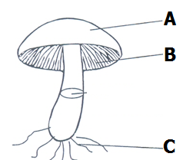

1. Name the organism shown in the diagram _______________________________________
2. To which kingdom of living things does it belong? _________________________________________________________________________
3. Name the part marked **A**.____________________________________________________
4. State the use of part **B** to the organism above.

_________________________________________________________________________

**SECTION A:**

1. In which state of matter is ice?

___________________________________________________________________________

1. Why are expectant mothers called vulnerable groups of people?

___________________________________________________________________________

113. State one duty of worker bees in the hive.

___________________________________________________________________________

114. How do green plants benefit from the process of respiration in animals?

___________________________________________________________________________

115. Name the class of food which protects our bodies from infection

___________________________________________________________________________

116. State one reason why we should boil drinking water.

___________________________________________________________________________

117. Which element of PHC controls the spread of immunisable diseases among infants?

___________________________________________________________________________

118. In which way is the reproduction of **yeast** different from **other fungi**?

___________________________________________________________________________

___________________________________________________________________________

119. How important is dustbin in our classroom?

___________________________________________________________________________

120. Identify the property of air shown below.

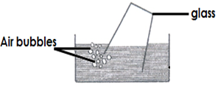

_______________________________________________

121. Give one example of a stem tuber

___________________________________________________________________________

122. Why is a dog referred to as a living thing?

___________________________________________________________________________

123. Mention one way in which our bodies acquire immunity.

___________________________________________________________________________

124. Give one poultry disease caused by a virus.

___________________________________________________________________________

125. Name one dairy breed of goats reared in Uganda.

___________________________________________________________________________

126. How is the life cycle of locusts different from that of butterflies?

___________________________________________________________________________

___________________________________________________________________________

127. Name the liquid metal which is commonly used in thermometers.

___________________________________________________________________________

128. Mention one similarity between fungi and bacteria..

___________________________________________________________________________

129. Why is evaporation of water to steam called a physical change?

___________________________________________________________________________

130. Explain the term **kindling** as usedin rabbit keeping.

___________________________________________________________________________

**Below is a diagram of a plant with a running stem, use it to answer questions 21 and 22.**

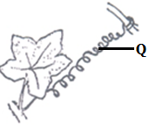

131. Name part labeled **Q** on the plant above?

_____________________________________________________2132. Give one reason why plants with such stems climb other

plants?

_____________________________________________________

_____________________________________________________

133. Identify one local method of preserving food.

_____________________________________________________

134. How does a crop farmer benefit from the action of worker bees visiting his tomato garden?

___________________________________________________________________________

135. Give one way of preventing burns while lifting hot objects.

___________________________________________________________________________

136. Why are poultry farmer encouraged to mix crushed bones of fish in poultry mash?

___________________________________________________________________________

137. Besides plants and animals, mention any other kingdom of living things.

___________________________________________________________________________

138. State one importance of heat to man.

___________________________________________________________________________

139. Give one importance of litter on a poultry house.

___________________________________________________________________________

140. Name one condition necessary for rusting to occur.

___________________________________________________________________________

141. Why is the space left in the bottle of soda below?

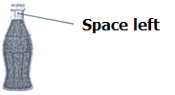

________________________________________________________________________

________________________________________________________________________

142. A part from the sun, identify any other natural source of heat energy.

___________________________________________________________________________

143. Why is a bat called a mammal yet it flies like birds?

___________________________________________________________________________

144. Name the most sensitive part of the tooth.

___________________________________________________________________________

145. How useful is an Anemometer at a weather station?

___________________________________________________________________________

146. Identify any one raw material for Photosynthesis

___________________________________________________________________________

147. In which part of the alimentary canal of man is alcohol absorbed?

___________________________________________________________________________

148. Why should pit latrines be smoked regularly?

___________________________________________________________________________

149. How is sleep and rest important for our well being?

___________________________________________________________________________

150. Mention one vaccine given to babies at 6, 10 and 14 weeks.

___________________________________________________________________________

**SECTION B,**

151.a) What are **vertebrates**?

___________________________________________________________________________

b) Besides birds, mention two other groups of vertebrates.

i)___________________________________ii)_____________________________________

c) Why are birds referred to as warm blooded vertebrates?

___________________________________________________________________________

152. **Below are roots of a monocotyledons plant, use the diagram to answer questions**

**that follow.**

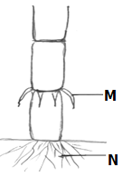

1. Name the part labeled **N**.

__________________________________________

1. How useful are roots marked M to the above plant?

____________________________________________

____________________________________________

c) Name any two plants with the root marked **M** above.

i)_____________________________________ii)___________________________________

153. How do the following animals protect themselves against enemies?

a) Caterpillars: _______________________________________________________________

b) Porcupines: _______________________________________________________________

c) Snakes: _______________________________________________________________

d) Chameleons: _______________________________________________________________

154.a) Which method of heat transfer enables a farmer to dry his harvested bean seeds?

__________________________________________________________________________

b) Identify any two examples of heat insulators.

i)__________________________________ii)_____________________________________

c) Why do electric wires appear tight during cold weather?  
 __________________________________________________________________________

155.a) How useful is Royal jelly in a bee hive?

__________________________________________________________________________

b) State one advantage of a **modern** bee hives over a **traditional** hives.

__________________________________________________________________________

__________________________________________________________________________

c) Name two products got from bees.

i)_____________________________________ii)___________________________________

156.a) Mention one example of each of the following :

i) Chemical change - ________________________________________________________

i) Biological change - _______________________________________________________

b) State one major similarity between **chemical** and **biological** changes.

___________________________________________________________________________

c) Which physical change leads to change of state from liquids to solids?

___________________________________________________________________________

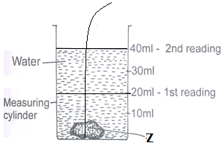157. **Study the experiment below and use it to answer questions that follow.**

a) Name the method of finding volume shown above.

___________________________________________________________________________

b) What scientific name is given to the object marked Z?

___________________________________________________________________________

c) Calculate the volume of the object marked Z in the diagram above.

__________________________________________________________________________

d) When is such a method of finding volume used?

__________________________________________________________________________

158.a) Name one exotic breed of sheep reared for wool production.

__________________________________________________________________________

b) Identify any one product made from wool. _______________________________________

c) How is docking an important practice in sheep management?

___________________________________________________________________________

d) Why is it not advisable for a farmer to live in the same house with domestic animals?

___________________________________________________________________________

159. **Study the diagram showing part of the digestive system of man and use it to**

**answer questions that follow.**

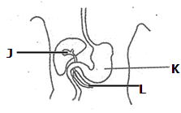

a) Name parts labeled **J andL**. i) **J**__________________________________

ii) **L** _________________________________

b) Which enzyme clots proteins in the milk of

babies in part labeled **K**?

_____________________________________

c) Suggest one way of keeping the digestive system in a good working condition.

___________________________________________________________________________

160. **Match the diseases in list A to the germs that cause them in list B**

**A B**

a) Malaria chlamydia

b) Typhoid HIV

c) AIDS Salmonella typhi

d) Trachoma Plasmodia

a) Malaria ____________________________

b) Typhoid ____________________________

c) AIDS ____________________________

d) Trachoma ____________________________

161. a) Name the thermometer used to measure the highest and lowest temperatures of the day.

__________________________________________________________________________

b) Give a reason why mercury is commonly used in most thermometers.

__________________________________________________________________________

c) How is BCG vaccine different from polio vaccine in the way they are administered?

___________________________________________________________________________

d) In which units is temperature measured?

___________________________________________________________________________

162.a) What is meant by the term immunity?

___________________________________________________________________________

b) Write down two ways in which our bodies acquire immunity.

i)__________________________________________________________________________

ii)__________________________________________________________________________

c) Mention one type of immunity.

___________________________________________________________________________

163.a) Mention any two components of soil.

i) _______________________________ ii) ______________________________________

b) Which type of soil is useful in pottery industry?

__________________________________________________________________________

c) Apart from pottery, give one other importance of soil to man.

___________________________________________________________________________

164**. The graph below shows the components of air. Use it to answer questions that**

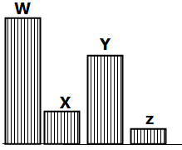 **follow.**

1. Which part of air is represented by the following

letters:

i) **W** _____________________

ii) **Z** _____________________

iii) **Y** _____________________

b) State any one use of gas labeled **Z** to man.

___________________________________________________________________________

165.a) Identify any one cause of road traffic accident in Uganda.

___________________________________________________________________________

b) Give one reason why casualties should be given First Aid.

___________________________________________________________________________

c) Name any two items which can be found in First Aid box.

i) __________________________________ ii)_________________________________

**-END-**